chapter thirteen
aggregate demand and aggregate supply

ANSWERS TO END-OF-CHAPTER QUESTIONS

13-1 What is the general relationship between a country’s price level and the quantity of its domestic output (real GDP) demanded? Who are the buyers of U.S. real GDP?

The general relationship is inverse; the aggregate demand (AD) curve shows that as the price level drops, the quantity of real GDP demanded increases.

The buyers of U.S. real GDP are households (consumption), businesses (investment), government (purchases of final goods and resources), and foreign buyers (exports).

13-2 Why is the long-run aggregate supply curve vertical? Explain the shape of the short-run aggregate supply curve. Why is the short-run curve relatively flat to the left of the full employment output and relatively steep to the right?

The long-run aggregate supply curve is vertical (at the full-employment or potential output) because the economy’s potential output is determined by the availability and productivity of real resources, not by the price level. The availability and productivity of real resources is reflected in the prices of inputs, and in the long run these input prices (including wages) adjust to match changes in the price level. Firms have no incentive to increase production to take advantage of higher prices if they simultaneously face equally higher resource prices.

The shape of the short-run supply curve is upsloping. Wages and other input prices adjust more slowly than the price level, leaving room for firms to take advantage of these higher prices (temporarily) by increasing output. Firms face increasing per unit production costs as they increase output, making higher prices necessary to induce them to produce more.

To the left of full-employment output the curve is relatively flat because of the large amounts of unused capacity and idle human resources. Under such conditions, per-unit production costs rise slowly because of the relative abundance of available inputs. Additional resources are easily brought into production, as the suppliers of these resources (especially labor) are anxious to employ them and are happy to accept current prices.

To the right of full-employment output the curve is relatively steep because most resources are already employed. Those resources that are not yet in production require higher prices to induce them, or generate higher per-unit production costs because they are less productive than currently employed inputs. Firms trying to increase production bid up input prices as they attempt to attract resources away from other firms. Even if the firm succeeds in pulling resources from another firm, the aggregate increase in output is minimal at best, as resources are merely shifted from one productive process to another.

13-3 Suppose that aggregate demand and supply for a hypothetical economy are as shown below:

Amount of  real domestic  output demanded,  billions |  | Price level  (price index) | Amount of  real domestic  output supplied,  billions
$100  200  300  400  500 |  | 300  250  200  150  100 | $450  400  300  200  100

a. Use these sets of data to graph the aggregate demand and aggregate supply curves. What is the equilibrium price level and the equilibrium level of real output in this hypothetical economy? Is the equilibrium real output also necessarily the full-employment real output? Explain.

b. Why will a price level of 150 not be an equilibrium price level in this economy? Why not 250?

c. Suppose that buyers desire to purchase $200 billion of extra real domestic output at each price level. Sketch in the new aggregate demand curve as AD₁. What factors might cause this change in aggregate demand? What is the new equilibrium price level and level of real output?

(a) See the graph. Equilibrium price level = 200. Equilibrium real output = $300 billion. No, the full-capacity level of GDP is more likely at $400 billion, where the AS curve starts to become steeper.

(b) At a price level of 150, real GDP supplied is a maximum of $200 billion, less than the real GDP demanded of $400 billion. The shortage of real output will drive the price level up. At a price level of 250, real GDP supplied is $400 billion, which is more than the real GDP demanded of $200 billion. The surplus of real output will drive down the price level. Equilibrium occurs at the price level at which AS and AD intersect.

(c) See the graph. Increases in consumer, investment, government, or net export spending might shift the AD curve rightward. New equilibrium price level = 250. New equilibrium GDP = $400 billion.

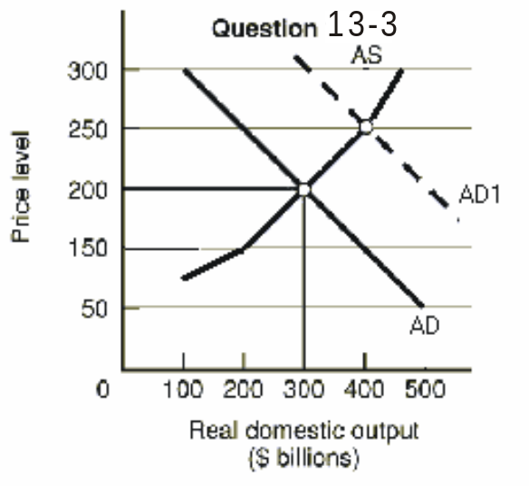

13-4 Suppose that a hypothetical economy has the following relationship between its real output and the input quantities necessary for producing that output:

a. What is productivity in this economy?

b. What is the per-unit cost of production if the price of each input is $2?

c. Assume that the input price increases from $2 to $3 with no accompanying change in productivity. What is the new per-unit cost of production? In what direction did the $1 increase in input price push the economy’s aggregate supply curve? What effect would this shift in aggregate supply have upon the price level and the level of real output?

d. Suppose that the increase in input price does not occur but instead that productivity increases by 100 percent. What would be the new per-unit cost of production? What effect would this change in per-unit production cost have on the economy’s aggregate supply curve? What effect would this shift of aggregate supply have on the price level and the level of real output?
Input  quantity |  | Real domestic  output
150.0  112.5  75.0 |  | 400  300  200

(a) Productivity = 2.67 (= 400/150; = 300/112.5; = 200/75.0)
- Per-unit cost of production = $.75 (= $2 x 112.5/300)
- New per-unit production cost = $1.13 (= $3 x 75/200). The AS curve would shift leftward. The price level would rise and real output would decrease.

(d) New per-unit cost of production = $0.375 (= $2 x 112.5/600). AS curve shifts to the right; price level declines and real output increases.

13-5 Other things equal, what effects would each of the following have on aggregate demand or aggregate supply? In each case use a diagram to show the expected effects on the equilibrium price level and the level of real output.

a. A reduction in the economy’s real interest rate.

b. A major increase in Federal spending for health care (with no increase in taxes).

c. The complete disintegration of OPEC, causing oil prices to fall by one-half.

d. A 10 percent reduction in personal income tax rates (with no change in government spending).

e. A sizable increase in labor productivity (with no change in nominal wages).

f. A 12 percent increase in nominal wages (with no change in productivity).

g. A sizable depreciation in the international value of the dollar.

(a) AD curve right, output and price level up.

(b) AD curve right, output and price level up (any real improvements in health care resulting from the spending would eventually increase productivity and shift AS right).

(c) AS curve right, output up and price level down.

(d) AD curve right, output and price level up.

(e) AS curve right, output up and price level down.

(f) AS curve left, output down and price level up.

(g) AD curve right (increased net exports); AS curve left (higher input prices)

13-6 Other things equal, what effect will each of the following have on the equilibrium price level and level of real output?

a. An increase in aggregate demand in the steep portion of the aggregate supply curve.

b. An increase in aggregate supply with no change in aggregate demand (assume that prices and wages are flexible upward and downward).

c. Equal increases in aggregate demand and aggregate supply.

d. A reduction in aggregate demand in the flat portion of the aggregate supply curve.

e. An increase in aggregate demand and a decrease in aggregate supply.

(a) Price level rises rapidly and little change in real output.

(b) Price level drops and real output increases.

(c) Price level remains unchanged and real output rises rapidly.

(d) Price level does not change (much or at all), but real output declines.

(e) Price level increases, but the change in real output is indeterminate.

13-7 Why does a reduction in aggregate demand reduce real output, rather than the price level?

A reduction in aggregate demand causes a decline in real output rather than the price level because prices are “sticky” or inflexible downward (ratchet effect). If we assume prices are completely inflexible downward, then a reduction in demand is essentially moving leftward and the aggregate supply curve is flat (horizontal), which means reduced output at a constant price. To say prices are completely inflexible downward may exaggerate but prices don’t fall easily for several reasons: wage contracts, minimum wage laws, employee morale, fear of price wars and the “menu cost” notion.

13-8 Explain: “Unemployment can be caused by a decrease of aggregate demand or a decrease of aggregate supply.” In each case, specify price-level effects.

The statement is true, although the magnitude of the effect on unemployment can vary considerably, particularly with decreases in aggregate demand. A decrease in aggregate supply will unambiguously increase the price level and reduce real output. With the decrease in output we would expect unemployment to rise. If the economy is operating above its full-employment output, a decrease in aggregate demand will have more modest effects on unemployment, having its strongest impact on the price level (reducing it). If aggregate demand falls while the economy is operating to the left of full-employment output, the increases in unemployment will be more substantial, and the effects on the price level weaker.

13-9 In early 2001 investment spending sharply declined in the United States. In the 2 months following the September 11, 2001, attacks on the United States, consumption also declined. Use AD-AS analysis to show the two impacts on real GDP.

Both events would be represented by a leftward shift in aggregate demand, and the initial declines in spending would be multiplied. (See Figure 13.2, shift from AD₁ to AD₃.) This would cause real GDP to drop and, assuming flexible prices, a drop in the price level. To the extent the drop in investment spending affected productivity, it could have either shifted AS left (if productivity dropped) or slowed the rightward movement of AS that occurred through much of the 1990s and into the early 2000s.

